**The Catchy Coin.**

***A Mini Project Report***

***Submitted in Partial Fulfilment for the award of***

**BACHELOR OF TECHNOLOGY**

**IN**

**COMPUTER SCIENCE AND ENGINEERING**

**(Specialization in Gaming Technology)**

***By***

**Arka Mazumdar (19BCG10020)**

**Arpit Singh (19BCG10069)**

**Kasturi Sai Gana Amruth(19BCG10083)**

**Yashvardhan Pandey (19BCG10089)**

***Under the Guidance of***

**Dr. Chandan Kumar Behera**



**SCHOOL OF COMPUTING SCIENCE AND ENGINEERING**

**VIT BHOPAL UNIVERSITY,**

**BHOPAL – 466 114, INDIA**

**October, 2020**

**Table of contents**

|  |  |  |
| --- | --- | --- |
| Serial no. | Topics | Page no. |
| 1 | Abstract | 3 |
| 2 | Introduction | 4 |
| 3 | Proposed Work | 7 |
| 4 | Software and Hardware requirements | 9 |
| 5 | UML diagrams | 11 |
| 6 | Screenshots of project work. | 12 |
| 7 | Conclusion | 16 |
| 8 | Reference. | 17 |

**Abstract**

This report describes the process involved in making a 2d side view game. We have made a game which is playable in Windows (PC) and Mobile platform. It discusses the overview of the game, its programming functions and describes the implementation of the game and is made in complete consideration of entertainment for the people. We have made this game user friendly and can be played by any age group.

**Introduction**

1. **Objective**

Catchy coin is 2d side view fantasy world game. It is playable on PC and android/ iOS, both the platforms. There are 3 waves in this game which the player has to clear by scoring a huge total of 3000 by collecting different types of fruits and rare coins. As this game follows life system process, there are 3 lives given at the first and the player should not lose his/her live in the game by avoiding the explosive bombs and the monkey and the pirate which will create hindrance while the player collects the fruits and coins and if the bomb falls on the player, the character will lose its 1 life every time.

2) **Brief of Existing Work**

The catchy coin is a 2d side-view fantasy game. This game is fast paced, challenging and an entertaining game. It is set in a magical world where the core mechanic and goal is to move the player and collect different types of fruits and coins through the basket, but have to avoid collecting bombs, the only obstacle in our game, or we lose our lives. The resource of the game is to get more points by collecting rare fruits and coins. We have three waves in which the speed of the game will increase double fold. We have to clear it to get our desired treasure. The resolutions is if the player loses all the lives the game will return to its starting point.

3) **Limitations Of Existing Work**

While making this game our team faced the following problems:-

1) Our team does not have much experience in 2D programming in unity.

2) The lack of proper resources like not enough screens for programming and game/scene arrangements.

3) Low budget constraints and Team members having different opinions on how the game works or should work which makes it little time consuming to get on the same page to work together.

4) Minor interaction with the teammates and lack of workspace and focus driven environment.

5) Animations didn’t look as we had expected because of low experience.

6) The lack of information on the usage of assets in a 2D environment made it hard to progress smoothly.

**Proposed Work**

1. **Brief Of Proposed Approach**

We first of all started with the making up of a story so that we can get a baseline story on which we will further be working on. After getting the story, we discussed what type dimension we will be working on, whether it should be 2D, 2.5D or 3D so that we can present our story based game in a very unique way.

Groups were made of 2 to work on each work, i.e. animation and scene, and the other was for the starting animation to give a background about the story of the game.

We then made the assets of the game, which then was used in our game to run the game. After the assets, the working on its animation was done and so was the working of the scenes.

The animation and scene management in which the main menu exists, was done separately and was integrated at the end together. Polishing and changes were made later.

2) **Advantages Of The Proposed System**

1. Making our groups divided into two each made the creation of the game complete with efficiency.
2. By deciding on the dimension, it helped us to view the game in that particular way and produce the game at its best.
3. The Standard assets which were used to affiliate with the creation of the game were quite notable as we didn’t expect it would turn out to be eye-catching.
4. The theme of the game thoroughly matched with the concept of our game.
5. The concept of our game perfectly matches with the 2d side view version if we use 3D it won’t look attractive. Instead it might turn out to be a boring game, as we were down on the fact of texturing in unity.
6. By doing the animation and the scene management separately, it helped us a lot to organize things in an individual manner, and when we had to integrate, we had nothing to do more than attaching the files together.
7. At the end, polishing the game helped us to review our thoughts on the final product and upgrade it at a slight mark to make the game look worth playing.

**Software and Hardware Requirements**

**Software Requirements**

1. Unity 3d
2. Paint 3D editor.
3. 32-bit/64-bit Windows OS.
4. Android/iOS.
5. 100 MB space.

**Hardware Requirements**

We have made a 2D side view game which is supported for PC as well as for mobile.

For Windows, we have the following hardware requirements:-

1. OS: Windows 7 SP1+
2. Processor: SSE2 instruction set support.
3. Memory: 1 GB RAM.
4. DirectX: Version 10.
5. Storage: 250 MB available space.

For Mobile, we have the following hardware requirements:-

1. Android, IOS, Mobile OS
2. Version- android 5.1 or High, IOS 6.0 or Higher
3. Processor – 480 or additional
4. Frequency – 2 GHz Min.

**UML Diagram**

The UML diagram of our game is the following:-

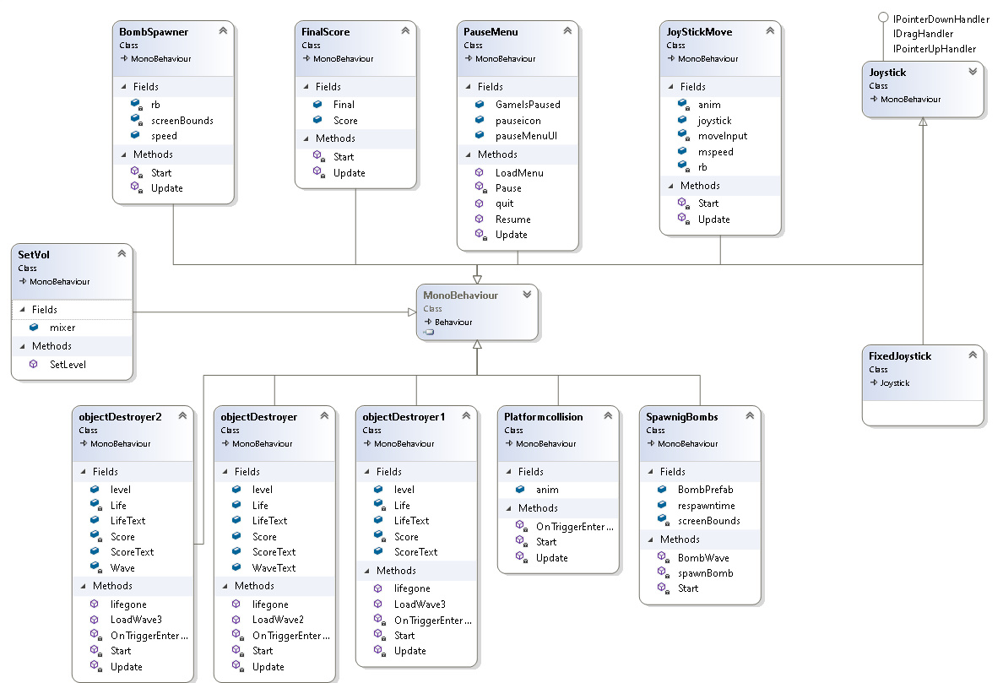

Fig:- The UML diagram of the game catchy coin.

**Screenshots of Our Project**

The screenshot for our game are as follows:-

**Main Menu**

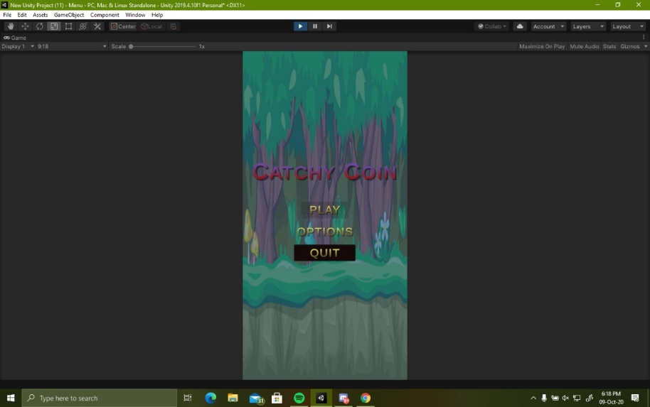

Fig:- The Game menu.

Main menu loads when the game is launched. It has 3 buttons which will help in navigating in the game scene

**Play-** it loads the main game scene to play

**Options-** it loads another text and buttons panel which has all the game settings like volume. Inside this it has a slider which increases or decreases the game volume

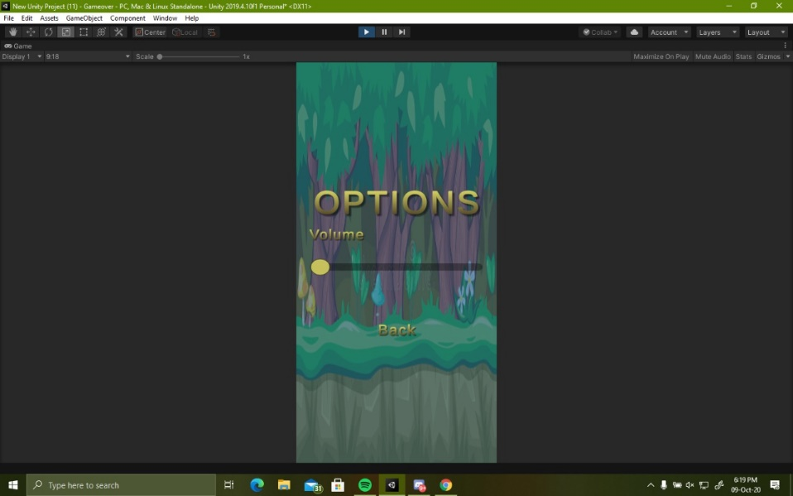

Fig:- The option button in game menu.

**Quit**- it closes the application when clicked

**Animations**

It has a color animation the catchy coin changes color

**Game Over Menu**

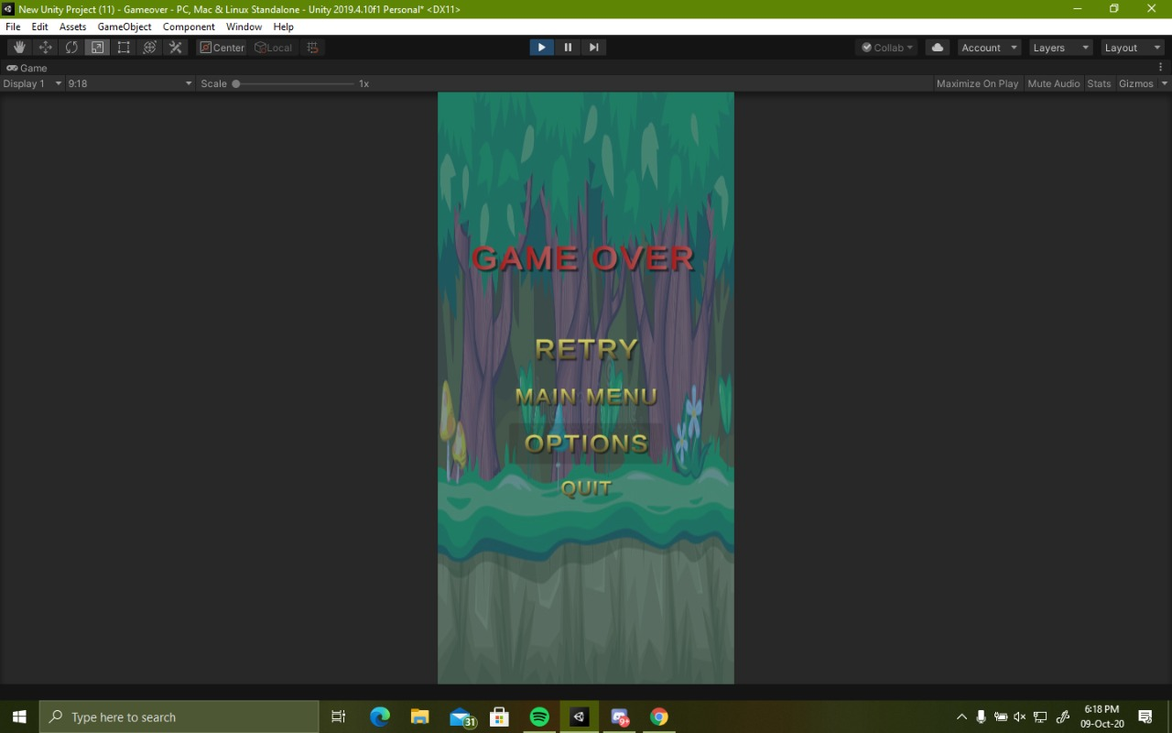

Fig:- The Game over menu.

Game over menu scene loads when all the 3 lives of the game character becomes zero. It has 4 buttons

**Retry-** It will load the main game again if player wants to play again

**Main Menu-** It will take us to the main menu which comes when game is launched

**Options-** it loads another text and buttons panel which has all the game settings like volume is same as the main menu options.

**Quit-** it closes the application when clicked

**Animations**

The game over in red color has an animation of scaling it increases size than decreases

**Winner Menu**

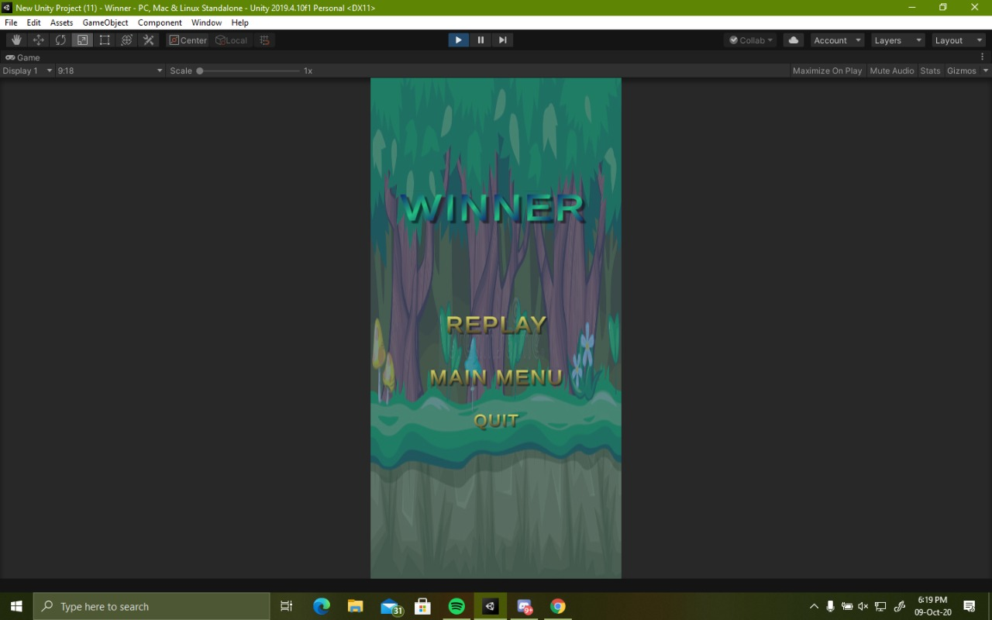

Fig:- The Winner menu

**Replay-** same as retry it will load the main game again if player wants to play again

**Main Menu-** It will take us to the main menu which comes when game is launched

**Quit-** it closes the application when clicked

**Animations**

The winner word has the same animation as game over it increases and decrease in the screen

It also has another animation of color which changes in gradient way

**Gameplay**

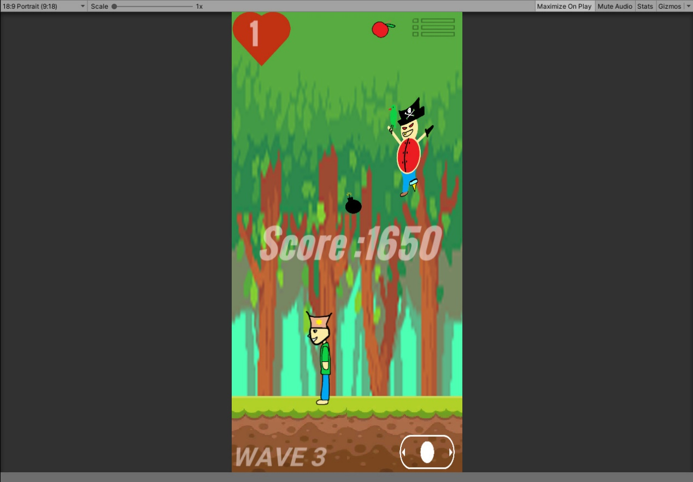

Fig:- The game play of the game “The catchy coin”.

This is the gameplay of our game, in which a pirate is creating hindrance in making the coins and fruits fall from the sky.

**Animations**

It has the animation of the Playable character, Thomas, who has to collect the fruits. The non-playable character, the pirate, which is creating hindrance, and the fruits and bombs which are randomly spawning so that the main character could collect them.

**Conclusion**

We have learnt a lot from this project and it has drastically sharpened our concept on game programming, animation software-hardware interface and learning about different types of documentation.

Working with game engine that too on a 2D environment was a completely new experience for use, where we learnt to make use of sprites and assets.

We made use of codes for each and every animation on our own, as we had to make changes at every point of the game to make it look better than our scratch idea.

Overall it was a great experience to be working on a game by using our own ideas in a coordinated way to give out an original game.

**Reference**

* <https://www.slideshare.net/NadiaIIT/final-project-report-of-a-game>.
* Unity asset store(Joystick only)
* Google.com (website).
* YouTube.com (tutorials).
* Unity official docs.
* Remove.bg (website).
* Unity scripting API.
* Google sprite spreadsheets (sprites).